Name : Anupam Kunwar
Reg : 19BCE1369
week-7

Packages

Q1.

MATRIX.java

package Anupam;
import java.util.Scanner;
public class MATRIX{
public int[][] arr = new int[3][3];
int i,j;
public MATRIX(){
for(i=0;i<3;i++){
for(j=0;j<3;j++){
arr[i][j] = 0;
}
}
}
public void readArr(){
Scanner in = new Scanner(System.in);
for(i=0;i<3;i++){
for(j=0;j<3;j++){
arr[i][j] = in.nextInt();
}
}
}
public void printArr(){
for(i=0;i<3;i++){
for(j=0;j<3;j++){
System.out.print(arr[i][j]+" ");
}
System.out.println();
}
}
public int[][] addArray(int[][] arr2){
int[][] sum = new int[3][3];
for(i=0;i<3;i++){
for(j=0;j<3;j++){
sum[i][j] = arr[i][j]+arr2[i][j];
}
}
return sum;
}
public int[][] subArray(int[][] arr2){
int[][] diff = new int[3][3];
for(i=0;i<3;i++){
for(j=0;j<3;j++){
diff[i][j] = arr[i][j]-arr2[i][j];
}
}
return diff;
}
}

testMatrix.java

import Anupam.MATRIX;
public class testMatrix{
public static void main(String[] args) {
MATRIX obj1 = new MATRIX();
MATRIX obj2 = new MATRIX();
MATRIX sum = new MATRIX();
MATRIX diff = new MATRIX();
System.out.println("\nEnter matrix1 elements : ");
obj1.readArr();
System.out.println("\nMatrix 1 elements are : ");
obj1.printArr();
System.out.println("\nEnter matrix2 elements : ");
obj2.readArr();
System.out.println("\nMAtrix 2 elements are : ");
obj2.printArr();
System.out.println("\nThe sum is : ");
sum.arr = obj1.addArray(obj2.arr);
sum.printArr();
System.out.println("\nThe difference is : ");
diff.arr = obj1.subArray(obj2.arr);
diff.printArr();
}
}

Output :
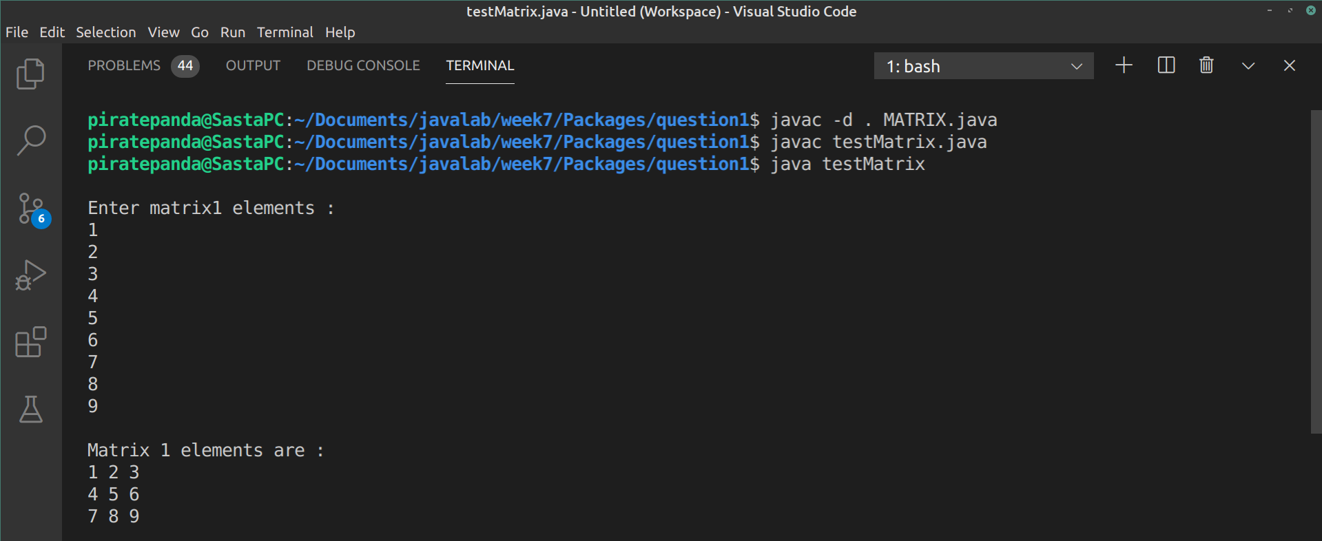
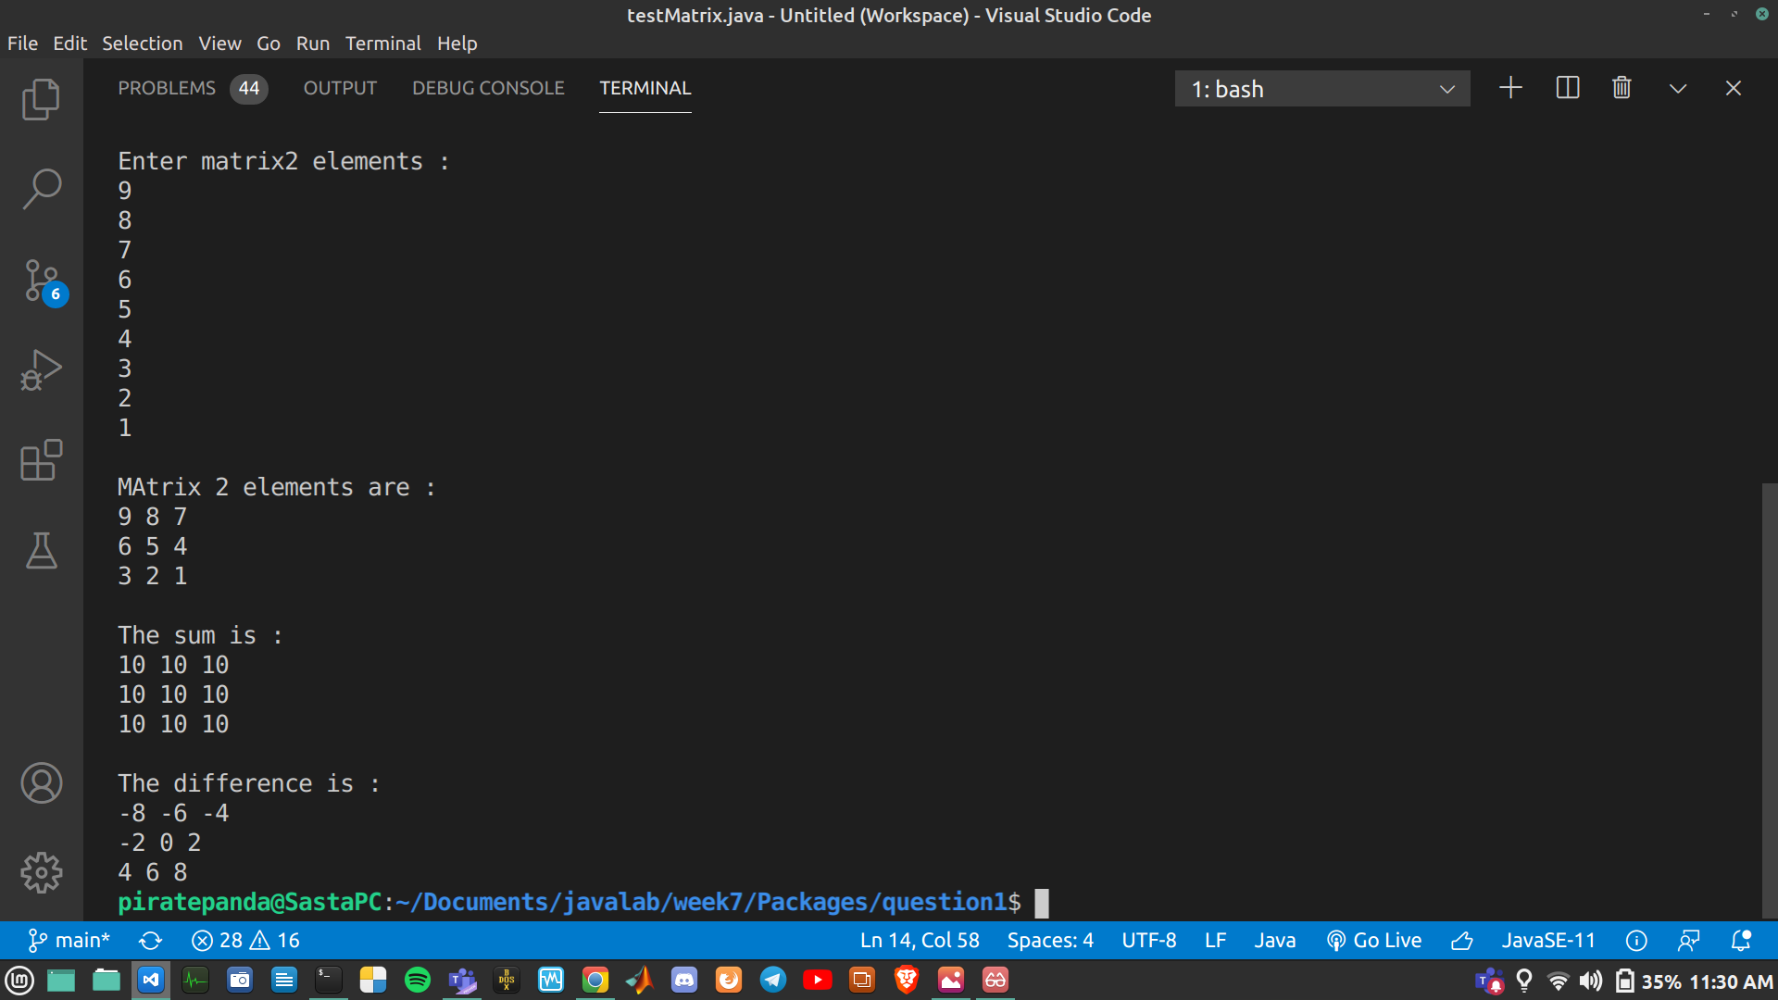
.

Q2.

person.java

package pack1;

public class person {
public String name;
public String sex;
public int age;

public person(String n, String s, int a){
name = n;
sex = s;
age = a;
}
}

staff.java

package pack2;

import pack1.person;

public class staff extends person {
public String dateOfJoin;
public int salary;
public staff(String name,String sex,int age,String doj,int sal){
super(name,sex,age);
dateOfJoin = doj;
salary = sal;
}
}

patient.java

package pack3;

import pack1.person;

public class patient extends person{
String condition;
int bill;
public patient(String name,String sex,int age,String cond,int b){
super(name,sex,age);
condition = cond;
bill = b;
}
public void display(){
System.out.println("Name = "+name);
System.out.println("Gender = "+sex);
System.out.println("Age = "+age);
System.out.println("Condition = "+condition);
System.out.println("Bill = "+bill);
}
}

doctor.java

package pack4;

import pack2.staff;

public class doctor extends staff{
String qualification;
String specialisation;
public doctor(String name,String sex,int age,String dateOfJoin,int salary,String qual,String spec){
super(name,sex,age,dateOfJoin,salary);
qualification = qual;
specialisation = spec;
}
public void display(){
System.out.println("Name = "+name);
System.out.println("Gender = "+sex);
System.out.println("Age = "+age);
System.out.println("Date of joining = "+dateOfJoin);
System.out.println("Salary = "+salary);
System.out.println("Qualification = "+qualification);
System.out.println("Specialisation = "+specialisation);
}
}

nurse.java

package pack5;

import pack2.staff;

public class nurse extends staff{
String type;
int shift;
public nurse(String name,String sex,int age,String dateOfJoin,int salary,String t,int sh){
super(name,sex,age,dateOfJoin,salary);
type = t;
shift = sh;
}
public void display(){
System.out.println("Name = "+name);
System.out.println("Gender = "+sex);
System.out.println("Age = "+age);
System.out.println("Date of joining = "+dateOfJoin);
System.out.println("Salary = "+salary);
System.out.println("Nurse Type = "+type);
System.out.println("Hours per day = "+shift);
}
}

HospitalDatabase.java

package mainPack;

import pack4.doctor;
import pack5.nurse;
import pack3.patient;

public class HospitalDatabase{
public static void main(String[] args) {
System.out.println("\nPatient : ");
patient patient1 = new patient("Arun","Male",24,"Cancer",20000);
patient1.display();
System.out.println("\nDoctor : ");
doctor doctor1 = new doctor("Vijay","Male",45,"02-02-00",50000,"MD","Gastro Intenstinal");
doctor1.display();
System.out.println("\nNurse : ");
nurse nurse1 = new nurse("Meera","Female",30,"03-03-02",35000,"Wet Nurse",8);
nurse1.display();
}
}

Output :

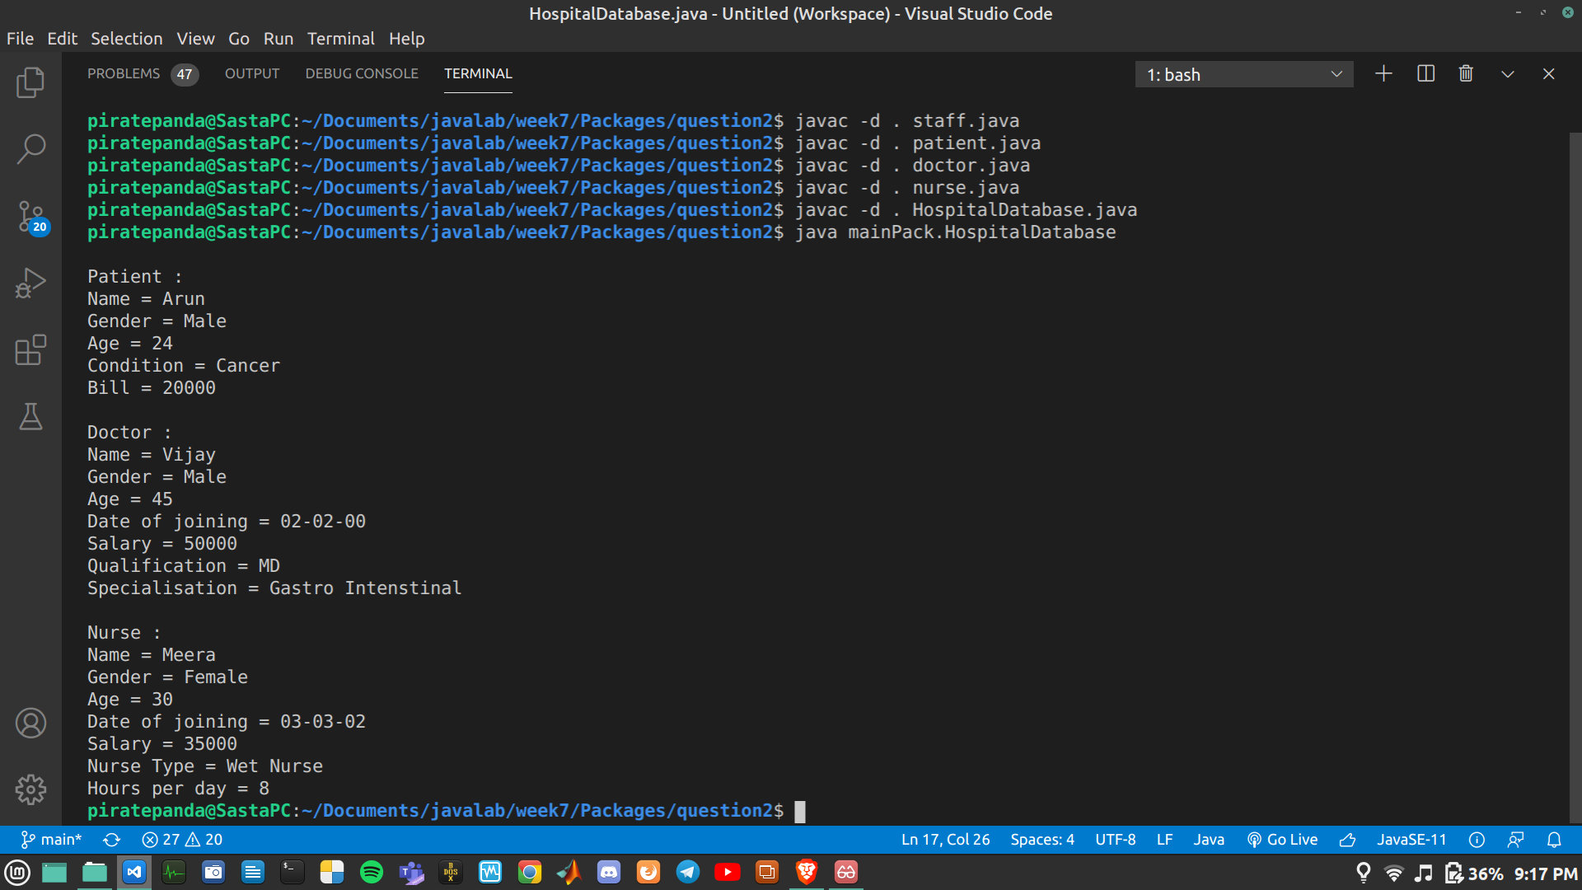
.

Interfaces

Q1.

interface volume{
public void innerVolume();
public void outerVolume();
}

class part implements volume{
double s1,s2,s3,iV,oV;
public part(double side1,double side2,double side3){
s1 = side1;
s2 = side2;
s3 = side3;
iV = 0.0;
oV = 0.0;
}
public void innerVolume(){
iV = (1.0/3.0)*(22.0/7.0)*s1*s2*s3;
}
public void outerVolume(){
oV = (4.0/3.0)*(22.0/7.0)*s1*s2*s3;
}
public void show(){
System.out.println("Inner volume = "+iV);
System.out.println("Outer Volume = "+oV);
}
}

public class q1 {
public static void main(String[] args) {
part obj = new part(2,3,4);
obj.innerVolume();
obj.outerVolume();
obj.show();
}
}

Output :
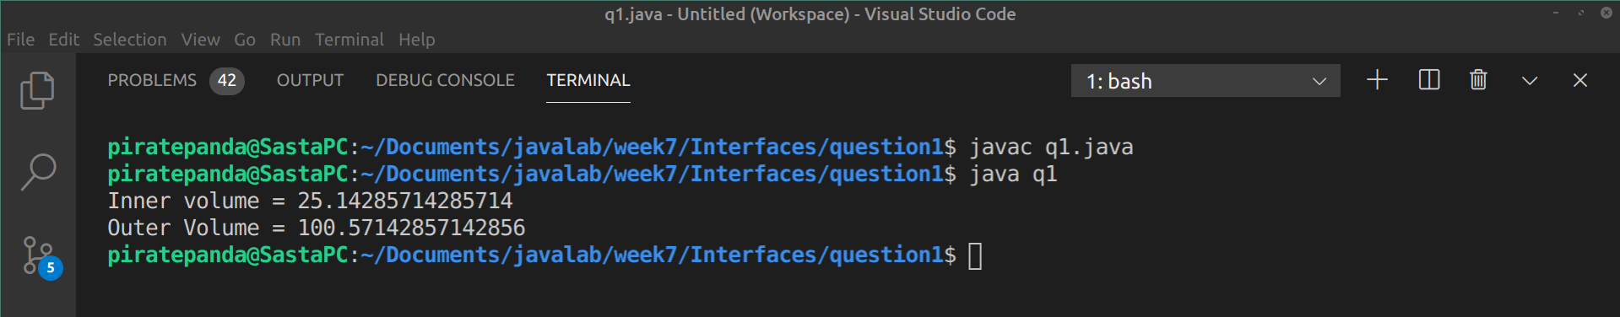
.

Q2.

animal.java

abstract class animal{
protected int legs;
protected animal(int l){
legs = l;
}
public void walk(){
System.out.println("Walking on "+legs+" legs");
}
public abstract void eat();
}

pet.java

interface pet{
public String getName();
public void setName(String n);
public void play();
}

spider.java

public class spider extends animal{
public spider(){
super(8);
}
public void eat(){
System.out.println("Spider is eating.");
}
}

cat.java

public class cat extends animal implements pet{
String name;
public cat(String n){
super(4);
name = n;
}
public cat(){
this("");
}
public String getName(){
return name;
}
public void setName(String n){
name = n;
}
public void play(){
System.out.println("Cat is playing.");
}
public void eat(){
System.out.println("Cat is eating.");
}
}

fish.java

public class fish extends animal implements pet{
public fish(){
super(0);
}
public void walk(){
System.out.println("Fish can't walk.They have "+legs+" legs");
}
public String getName(){
return null;
}
public void setName(String n){
}
public void play(){
System.out.println("Fish is playing.");
}
public void eat(){
System.out.println("Fish is eating.");
}
}

testAnimals.java

public class testAnimals{
public static void main(String[] args) {
fish d = new fish();
cat c = new cat("Fluffy");
animal a = new fish();
animal e = new spider();
pet p = new cat();
System.out.println();
d.play();
d.eat();
d.walk();
d.setName("Albert");
System.out.println("Name = "+d.getName());
System.out.println();
c.play();
c.eat();
c.walk();
System.out.println("Name = "+c.getName());
c.setName("Tom");
System.out.println("Name = "+c.getName());
System.out.println();
a.eat();
a.walk();
System.out.println();
e.eat();
e.walk();
System.out.println();
p.play();
p.setName("Robin");
System.out.println("Name = "+p.getName());
}
}

Output :
